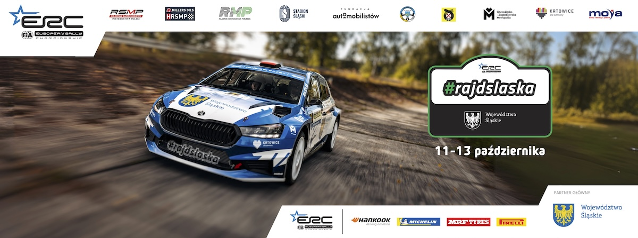
Informacja prasowa, 12 października 2024 r.

Rally Silesia: report after SS 4 – New Zealanders in the lead

Just one second separates the leaders from the second crew in the Silesia Rally standings. Having completed the first four stages of the final ERC round, Hayden Paddon and John Kennard (Hyundai i20 Rally2) hold a narrow lead. Andrea Mabellini and Virginia Lenzi (Skoda Fabia RS Rally2) are just a second adrift of the rally leaders. Marczyk and Gospodarczyk are third overall despite being off the road on SS 3. This mistake cost them dearly as the gap to Paddon increased to 18 seconds.

After Friday evening’s opener on the streets of Katowice, on Saturday, the competitors set off to the south of the Silesian Voivodeship to tackle three special stages there. Three speed tests were scheduled for the first loop: Jastrzębie-Zdrój (17.04 km), Ochaby (10.8 km), and Jasienica (19.78 km) – the longest stage of the Polish ERC counter.

It were Mikolaj Marczyk and Szymon Gospodarczyk who left the service park at Silesian Stadium as rally leaders. Poles topped the leaderboard after winning the spectacular superspecial in Katowice (1,85 km).

Low grip surprised ERC frontrunners

The chilly morning, combined with the very varied tarmac where grip changes surprisingly often, meant that the drivers unanimously remarked on how slippery the special stages were during the morning loop. This did not make tyre choice any easier. Some crews opted for tyres made of a medium-hard compound, which were more difficult to warm up to the working temperature.

Defending champion Hayden Paddon and John Kennard set the pace already on the opening stage in Jastrzębie-Zdrój. The New Zealanders only need to finish the Silesia Rally in fifth place to celebrate their second consecutive European championship title in Chorzów. Paddon's time over the 17-kilometre course was 1.7 seconds better than that result achieved by Andrea Mabellini and Virginia Lenzi (Skoda Fabia RS Rally2). Grzegorz Grzyb and Adam Binięda (Skoda Fabia RS Rally2) proved how competitive they are on home soil, clocking 3rd fastest time, just 5.8s slower than stage winners.

On the Ochaby stage, crews faced a 700-metre-long gravel section and a winding, bumpy section through a forest, where some crews were in trouble. On the gravel section, Marczyk and Gospodarczyk went off the road for a moment, while Matulka and Dymurski spun in the forest, hitting a tree, fortunately without serious consequences.

The results of the Ochaby test were a replay of the previous stage, with Paddon setting the pace. Mabellini and Grzyb came second (+2.2s) and third (+3.0s), respectively. Marczyk lost 10 seconds to Paddon what saw him drop to sixth overall.

The final stage of the loop, held in Gmina Jasienica, was won by Irish duo Jon Armstrong/Eoin Treacy (Ford Fiesta Rally2), even though they went wide in one of the tight corners. Mabelini and Lenzi were 0.2s slower. Paddon and Kennard finished third, losing 2.4s. Marczyk clocked the fourth fastest time (+4.4s), while Grzyb’s efforts were only enough to score the seventh result. Due to this, Marczyk climbed back to third overall, dropping Grzyb to fourth place.

Simone Tempestini and Francesca Maior (Skoda Fabia RS Rally2) finished the morning loop holding 5th overall, 19.6 s adrift of the leaders.

Rally leaders do not take risks on the demanding Silesian stages

– I’m not putting a year’s hard work behind us to fight for a rally win. We’re just keeping a safe place now, and we’re pretty comfortable doing what we’re doing. But it’s tricky conditions because the grip is changing a lot, and you need some margin in these conditions – Paddon said.

– It seems everything is working this morning, and it’s a little bit easier, let’s say. We’ve had a good morning and are happy, Mabellini concluded.

- The grip was diverse. I did my best to push in sections where the grip was better – Marczyk said, who is top-placed Pole in events’ standings.

Marczyk, third overall, leads the Polish championship standings. He is followed by Grzyb (+1.3s), fighting for his fourth title. Byśkiniewicz and Siatkowski (Skoda Fabia Rally2 evo) are third in the RSMP classification, but they are already 18.2 s away from Grzyb. The Szeja brothers (Skoda Fabia Rally2 evo), leaders of the championship standings, hold fourth place, a result that secures them their maiden Polish championship title. - We took two soft tyres from the service, which was a safe choice. We control our pace and do our job, being cautious in the tricky, slippery places – Szeja said.

Among the crews in Rally3 cars, a passionate duel is being fought between a Swede and a Pole. Mille Johansson, thus the newly crowned European junior champion, is fending off charges of Hubert Laskowski, who recently sealed the Polish championship in class 4. Laskowski, however, is not registered as the ERC, so his battle with the Swede is a bit virtual. Johansson, co-driven by Johan Gronvall (Ford Fiesta Rally3), won the first two stages. Hubert Laskowski and Michal Kuśnierz answered, setting the fastest time on SS 4. Eventually, after four stages, Laskowski is just 1.4s behind Johansson.

In the 2WD category, Calle Carlsberg, co-driven by Norwegian Jorgen Eriksen (Opel Corsa Rally4), tops the leaderboard. Marek Nowak and Adam Grzelka (Opel Corsa Rally4) are top-placed Poles in this category.

Crews in historic cars have also completed four stages. Marcin Majcher and Daniel Leśniak in the Subaru Legacy 4WD Turbo lead the Millers Oils HRSMP classification. The leaders of the series standings are followed by Bartłomiej Madziara and Mateusz Pawłowski (Subaru Impreza, +1:18.0 s), while Filip Stopa and Rafał Ślęczka (BMW E36 M3, +1:26.0 s) hold third place.

The second runs of Jastrzebie-Zdroj, Ochaby, and Gmina Jasienica are scheduled for the afternoon loop. Saturday’s leg will be concluded with an evening super special at the meadows of Silesian Stadium.

Rally Silesia – FIA ERC standings after SS 4:

1. Paddon/Kennard (NZL/NZL, Hyundai i20N Rally2) 28:46,8 s
2. Mabellini/Lenzi (ITA/ITA, Skoda Fabia RS Rally2) +1,0 s
3. Marczyk/Gospodarczyk (POL/POL, Skoda Fabia RS Rally2) +18,0 s
4. Grzyb/Binięda (POL/POL, Skoda Fabia RS Rally2) +19,3 s
5. Tempestini/Maior (ROU/ROU, Skoda Fabia RS Rally2) +19,6 s
6. Franceschi/Malfoy (FRA/FRA, Skoda Fabia RS Rally2) +26,9 s
7. Byśkiniewicz/Siatkowski (POL/POL, Skoda Fabia Rally2 evo) +36,2 s
8. Szeja/Szeja (POL/POL, Skoda Fabia Rally2 Evo) +38,5 s
8. Gabryś/Syty (POL/POL, Skoda Fabia RS Rally2) +38,5 s
10. Bonato/Bolloud (FRA/FRA, Citroen C3 Rally2) +38,7 s

Rally Silesia – RSMP standings after SS 4:

1. Marczyk/Gospodarczyk (Skoda Fabia RS Rally2) 29:04,8 s
2. Grzyb/Binięda (Skoda Fabia RS Rally 2) +1,2 s
3. Byśkiniewicz/Siatkowski (Skoda Fabia Rally2 evo) +18,1 s
4. Szeja/Szeja (Skoda Fabia Rally2 evo) +20,5 s
4. Gabryś/Syty (Skoda Fabia RS Rally2) +20,5 s
6. Kołtun/Pleskot (Skoda Fabia RS Rally2) +36,5 s
7. Matulka/Dymurski (Skoda Fabia Rally2 evo) +45,3 s
8. Laskowski/Kuśnierz (Ford Fiesta Rally3) +1:16,0 s
9. Krotoszyński/Martynek (Skoda Fabia Rally2 evo) +1:25,9 s
10. Tochowicz/Białowąs (Citroen C3 Rally2) +1:36,6 s

Rally Silesia 2024 itinerary

Friday, 11 October (1 special stage, 1,85 km in total)

8:30 – 11:00 – free practice: GZM (Zabrze Mikulczyce, 3,05 km)
11:31 – qualifying stage GZM (Zabrze Mikulczyce, 3,05 km)
13:00 – shakedown GZM (Zabrze Mikulczyce, 3,05 km)
18:00 – ceremonial start (ul. Dworcowa, Katowice)
20:05 – SSS 1: Katowice (1,85 km)

Saturday, 12 October (7 special stages, 96,74 km in total)

7:20 – service A: 15 min (Silesian Stadium, Chorzów)
9:00 – SS 2: Jastrzębie Zdrój (17,04 km)
10:00 – SS 3: Ochaby (10,8 km)
11:00 – SS 4: Gmina Jasienica (19,78 km)
13:20 – service B: 30 min (Silesian Stadium, Chorzów)
15:15 – SS 5: Jastrzębie Zdrój (17,04 km)
16:15 – SS 6: Ochaby (10,8 km)
17:15 – SS 7: Gmina Jasienica (19,78 km)
19:30 – SS 8: Silesian Stadium (1,5 km)
19:50 – service C: 45 min (Silesian Stadium, Chorzów)

Sunday, 13 October (7 special stages, 81,56 km in total)

7:20 – service D: 15 min (Silesian Stadium, Chorzów)
8:55 – SS 9: Marklowice Górne (11,46 km)
9:55 – SS 10: Hażlach (17,45 km)
11:05 – SS 11: Silesian Voivodeship (Kiczyce, 11,87 km)
12:40 – tyre fitting zone: 15 min (Carbonarium Moszczenica)
13:10 – SS 9: Marklowice Górne (11,46 km)
14:10 – SS 10: Hażlach (17,45 km)
16:05 – SS 11: Silesian Voivodeship – Power Stage (Kiczyce, 11,87 km)
18:30 – finish ceremony (Silesian Stadium, Chorzów)

====================================================================

Rally Silesia– information:

The first edition of the Rally Silesia took place in 2017, immediately as a round of the Polish Championship – the most important rally series in our country. In the following years, the event was gradually developed – competitors in historic rally cars joined the participants, the Rally Silesia emerged new Polish champions and a spectacular show was organized – a special stage in the center of Katowice. In 2023, the competition gained international rank, becoming part of the European Rally Trophy (FIA ERT). It also gained recognition from the World Automobile Federation (FIA) and the promoter of the European Championship, which resulted in the promotion of the Rally Silesia to the FIA European Rally Championship (FIA ERC) – the second most important series in the world.

The honorary patronage over the competition was assumed by Wojciech Saługa, Marshal of the Silesian Voivodeship.

The main partner of the Rally Silesia is the Silesian Voivodeship.

The strategic partner of the Rally Silesia is the GZM Metropolis.

The city of Katowice is a co-host of the event, and the MOYA brand is a partner of the Rally Silesia. The Silesian Stadium in Chorzów is a co-organizer of the competition.

The event's partner is also the Ministry of Sport and Tourism, and the task was co-financed from the state budget from the part administered by the Minister of Sport and Tourism.

All information about the Rally Silesia can be found on the website www.rallysilesia.com Facebook @rajdslaska, Instagram @rajd_slaska and Twitter @RajdSlaska.
