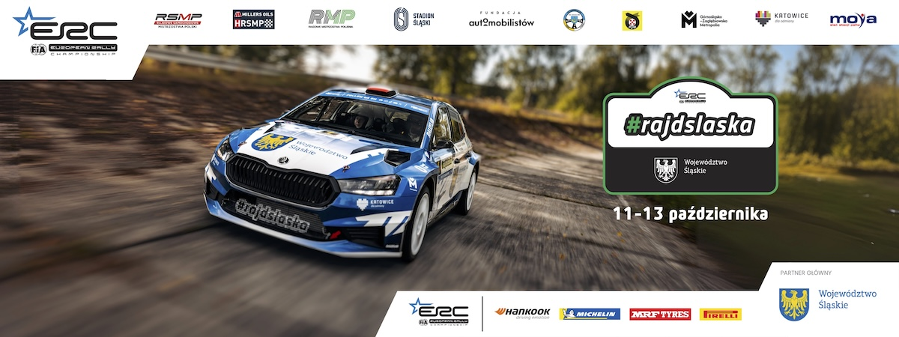
Press release, 11 October 2024 r.

Title contender Franceschi fastest in qualifying – Rally Silesia is underway

The French crew Mathieu Franceschi/Andy Malfoy (Skoda Fabia RS Rally2) were fastest on the GZM Metropolis test (3.05 km), held as the qualifying stage of Rally Silesia, the final round of the European and Polish championships. The results clocked on the qualifying stage determine the starting order in Saturday’s leg of the rally

Although the results of the qualifying stage do not count towards the overall classification of the event, they may be crucial. According to the series' regulations, the order in which the FIA ERC frontrunners start the stages during the first leg of the rally is determined by qualifying stage classification.
Running order is most important in gravel rallies, where the first crews sweep the loose gravel and dust so that the next competitors have better grip and can drive faster.
On the other hand, in tarmac rounds - such as the Rally of Silesia - it is better to start as first, second or third crew, as the conditions on the stages get worse after each car, especially when it rains. Hence, the qualifying section is an important part of the rally strategy.

Frenchmen sets the pace
The 2024 FIA ERC season showdown kicked off on Friday, 11th of October, with GZM free-practice and qualifying stage (3,05 km). The strategic partner of the Silesia Rally is Metropolis GZM, and the qualifying stage is named after the first metropolitan unit in Poland.

It were Mathieu Franceschi and Andy Malfoy (Skoda Fabia RS Rally2, 1:43.1 s) who set the fastest time in Zabrze Mikulczyce, where QS has been located. – I felt good on this stage. This is the last rally of the season, so I want to have fun. Reaching for the title will be difficult, so I want to enjoy and show a good pace. I'm happy to be first on the road because every other crew will be throwing the mud and dirt on the road – said Franceschi.

Andrea Mabellini and Virginia Lenzi (Skoda Fabia RS Rally2) were second fastest for Team MRF Tyres in a time of 1min 44.2sec, followed by home heroes Miko Marczyk and Szymon Gospodarczyk (Skoda Fabia RS Rally2), who were 0.2sec behind, and championship leaders Hayden Paddon and John Kennard (Hyundai i20N Rally2). Behind Paddon, Jon Armstrong and Eoin Treacy clocked the fifth time in his Pirelli-equipped Ford Fiesta Rally2 with Romanian duo Simone Tempestini/Francesca Maior next up after a brief slide (Skoda Fabia RS Rally2).

Szeja brothers (Skoda Fabia Rally2 evo), Polish championship leaders, shone among the series regulars, finishing 8th overall. The crew from Ustron was followed by Jakub Matulka and Daniel Dymurski (Skoda Fabia Rally2 evo) and Jarek Koltun with Ireneusz Pleskot (Skoda Fabia RS Rally2).
Start and evening show in Katowice
The city of Katowice, which is the event’s co-host, is where the opening ceremony will take place, followed by a spectacular superspecial stage (1,85 km), which runs in the heart of the city, around the Spodek – a multipurpose arena in Katowice and one of the symbols of the city.

The opening stage of the 2024 FIA ERC season showdown will be broadcast live by TVP Sport and Motowizja. The latter provides live coverage from every special stage of ERC and WRC rounds.
The teams will compete on the streets of Katowice in reverse order, which means that the fans will see the fastest and most powerful cars at the end.
On Saturday, on the other hand, the competitors will set off for the individual stages according to the results of the qualifying stage (below).

Rally Silesia 2024 – GZM Qualifying stage results:

1. Franceschi/Malfoy (FRA/FRA, Skoda Fabia RS Rally2) 1:43,989 s
2. Mabellini/Lenzi (ITA/ITA, Skoda Fabia RS Rally2) +0,18 s
3. Marczyk/Gospodarczyk (POL/POL, Skoda Fabia RS Rally2) +0,389 s
4. Paddon/Kennard (NZL/NZL, Hyundai i20N Rally2) +0,664 s
5. Armstrong/Treacy (IRL/IRL, Ford Fiesta Rally2) +0,755 s
6. Tempestini/Maior (ROU/ROU, Skoda Fabia RS Rally2) +0,972 s
7. Bonato/Bolloud (FRA/FRA, Citroen C3 Rally2) +0,972 s
8. Szeja/Szeja (POL/POL, Skoda Fabia Rally2 evo) +1,623 s
9. Matulka/Dymurski (POL/POL, Skoda Fabia Rally2 evo) +1,81 s
10. Kołtun/Pleskot (POL/POL, Skoda Fabia RS Rally2) +2,143 s
11. Gabryś/Syty (POL/POL, Skoda Fabia RS Rally2) +2,575 s
12. Grzyb/Binięda (POL/POL, Skoda Fabia RS Rally2) +2,828 s
13. Byśkiniewicz/Siatkowski (POL/POL, Skoda Fabia Rally2 evo) +3,043 s
14. Evans/Jackson (GBR/GBR, Toyota GR Yaris Rally2) +3,877 s
15. Kwiatkowski/Kozdroń (POL/POL, Skoda Fabia Rally2 evo) +4,62 s

Rally Silesia 2024 itinerary

Friday, 11 October

- 18:00 – opening ceremony (ul. Dworcowa, Katowice)
- 20:05 – SS 1: Katowice (1,85 km)

Saturday, 12 October (7 special stages, 96,74 km in total)

- 7:20 – service A: 15 min (Stadion Śląski, Chorzów)
- 9:00 – SS 2: Jastrzębie Zdrój (17,04 km)
- 10:00 – SS 3: Ochaby (10,8 km)
- 11:00 – SS 4: Gmina Jasienica (19,78 km)
- 13:20 – service B: 30 min (Stadion Śląski, Chorzów)
- 15:15 – SS 5: Jastrzębie Zdrój (17,04 km)
- 16:15 – SS 6: Ochaby (10,8 km)
- 17:15 – SS 7: Gmina Jasienica (19,78 km)
- 19:30 – SS 8: Stadion Śląski (1,5 km)
- 19:50 – service C: 45 min (Stadion Śląski, Chorzów)

Sunday, 13 October (6 special stages, 81,56 km in total)

- 7:20 – service D: 15 min (Stadion Śląski, Chorzów)
- 8:55 – SS 9: Marklowice Górne (11,46 km)
- 9:55 – SS 10: Hażlach (17,45 km)
- 11:05 – SS 11: Silesian Voivodeship (Kiczyce, 11,87 km)
- 12:40 – tyre fitting zone: 15 min (Carbonarium Moszczenica)
- 13:10 – SS 9: Marklowice Górne (11,46 km)
- 14:10 – SS 10: Hażlach (17,45 km)
- 16:05 – SS 11: Silesian Voivodeship – Power Stage (Kiczyce, 11,87 km)
- 18:30 – finish ceremony (Stadion Śląski, Chorzów)

Rally Silesia– information:

The first edition of the Rally Silesia took place in 2017, immediately as a round of the Polish Championship – the most important rally series in our country. In the following years, the event was gradually developed – competitors in historic rally cars joined the participants, the Rally Silesia emerged new Polish champions and a spectacular show was organized – a special stage in the center of Katowice. In 2023, the competition gained international rank, becoming part of the European Rally Trophy (FIA ERT). It also gained recognition from the World Automobile Federation (FIA) and the promoter of the European Championship, which resulted in the promotion of the Rally Silesia to the FIA European Rally Championship (FIA ERC) – the second most important series in the world.

The honorary patronage over the competition was assumed by Wojciech Saługa, Marshal of the Silesian Voivodeship.

The main partner of the Rally Silesia is the Silesian Voivodeship.

The strategic partner of the Rally Silesia is the GZM Metropolis.

The city of Katowice is a co-host of the event, and the MOYA brand is a partner of the Rally Silesia. The Silesian Stadium in Chorzów is a co-organizer of the competition.

The event's partner is also the Ministry of Sport and Tourism, and the task was co-financed from the state budget from the part administered by the Minister of Sport and Tourism.

All information about the Rally Silesia can be found on the website www.rallysilesia.com Facebook @rajdslaska, Instagram @rajd_slaska and Twitter @RajdSlaska.

