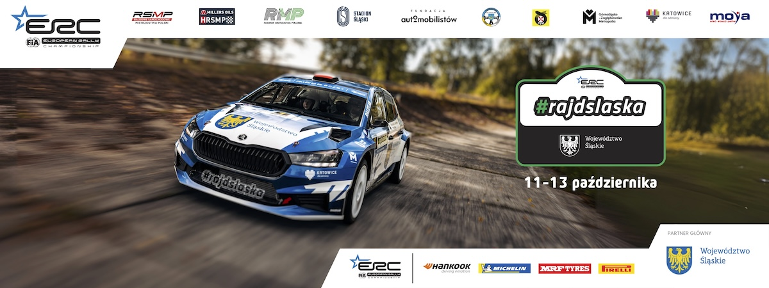
Press release, 2nd of October 2024 r.

110 crews in Rally Silesia – FIA ERC season showdown

220 competitors from 13 countries will tackle bumpy and demanding special stages of Rally Silesia (11-13 October), which will conclude the European and Polish championship season. Among the entrants are FIA ERC title contenders, including the reigning champion, who comes from a town located as far as 17,728 km from the event’s HQ at Silesian Stadium in Chorzow.

The FIA ERC title fight is still open after running seven out of eight rounds scheduled for the 2024 season. It all comes down to Rally Silesia. The series’ final round results will decide who seals the title.

In addition to the FIA ERC crews, the participants of the Polish Rally Championship (RSMP), Millers Oils Polish Historic Rally Championship (HRSMP) and Southern Poland Rally Championship (RMP) – a series of regional events - will compete on tarmac special stages in the Silesian Voivodship.

18 000 kilometres of title chase

Seeded at number one are the reigning champions and championship leaders Hayden Paddon and John Kennard (Hyundai i20N Rally2, 131 points). To compete in Silesia Paddon must cover nearly 18,000 kilometres, separating the town where he lives from the rally HQ at the Silesian Stadium. The New Zealanders are a former Hyundai WRC team crew. Paddon has competed in 83 WRC rounds, scoring eight top-three finishes, including one victory sealed in 2016 Rally Argentina. Moreover, Paddon has seven New Zealand championship titles under his belt and was crowned APRC champion in 2022. Kiwi is the first non-European driver to clinch the FIA ERC title (2023).

Mathieu Franceschi and Andy Malfoy are second on the event entry list (Skoda Fabia RS Rally2). The French duo has 104 points to their credit and is the only one to retain their chances of beating Paddon and Kennard.

Mikolaj Marczyk and Szymon Gospodarczyk (#3, Skoda Fabia RS Rally2) will fight for the runner-up spot during their home round of the FIA ERC. The two-time Silesia Rally winners have accumulated 91 points so far. The start in Silesia has also been announced by competitors who have already won rounds of the European championship, namely Romanians Simone Tempestini/Sergio Itu (Skoda Fabia RS Rally2) and Frenchmen Yoann Bonato and Benjamin Bolloud (Citroen C3 Rally2). 33 crews will compete in the European Championship round, including 14 duos from Poland.

Five crews to fight for the Polish championship title

The event, whose leading partner is the Silesian Voivodship, is also crucial in the fight for supremacy in the national championship. A total of 32 crews have entered the final round of the RSMP. Five of them remain in the game for the title of Polish champions. Jarek and Marcin Szeja (Skoda Fabia Rally2 evo, 132 points) hold the championship leaders position. Grzegorz Grzyb, co-driven by Adam Binięda (Skoda Fabia Rally2 evo, 111 points), fights for his fourth Polish champion title. Jakub Matulka and Daniel Dymurski (Skoda Fabia Rally2 evo) have scored as many points as Grzyb and Binieda. Among the title contenders are Zbigniew Gabryś and Damian Syty (Skoda Fabia RS Rally2, 106 points) and the 2023 RSMP runners-up, Łukasz Byśkiniewicz and Daniel Siatkowski (Skoda Fabia Rally2 evo, 88 points). As many as 50 points towards the national championship can be scored during the Rally Silesia.

Thirteen crews will fight for victory in the 2WD classification (two-wheel drive cars), while five duos will compete in Rally3 cars.

Four rally series, diverse line-up

As in previous years, fans will enjoy historic cars tackling the route of the Rally Silesia. As many as 16 crews decided to take part in the decisive round of the Millers Oils HRSMP. Among the historic are Subaru Impreza, Subaru Legacy, Porsche 911, Lancia Delta Integrale or... Trabant 601. The oldest car in the field is a 1979 BMW 320i entered by Piotr and Izabela Filipiak. As in the RSMP, five duos are in the game for the title. They are: Majcher/Leśniak (Subaru Legacy, 107 points), Madziara/Pawłowski (Subaru Impreza, 98 points), Stopa/Ślęczka (BMW M3 E36, 94 points), Łusiak/Zaborowska (Ford Escort Cosworth, 65 points) and Lubiak/Dachowski (Porsche 911 SC RS, 63 points).

Meanwhile, 40 crews entered the Southern Poland Rally Championship round, a series of regional events shorter than rounds of the Polish or European championship. Kacper Potyra, co-driven by Piotr Sieliło (Citroen DS3 THP), leads the series standings.
110 crews – 220 competitors from 13 countries, will participate in this year's Rally Silesia. 22 crews will use Rally2 machinery – the fastest and most advanced cars eligible in FIA ERC rounds, while the total number of 4WD cars is 37.

[PDF] Entry list – Rally Silesia – 8th round of FIA ERC 2024
[PDF] Entry list – Rally Silesia – 6th round of RSMP 2024
[PDF] Entry List – Rally Silesia – 6th round of Millers Oils HRSMP 2024
[PDF] Entry list – Rally Silesia – 4th round of RMP 2024

Rally Silesia– information:

The first edition of the Rally Silesia took place in 2017, immediately as a round of the Polish Championship – the most important rally series in our country. In the following years, the event was gradually developed – competitors in historic rally cars joined the participants, the Rally Silesia emerged new Polish champions and a spectacular show was organized – a special stage in the center of Katowice. In 2023, the competition gained international rank, becoming part of the European Rally Trophy (FIA ERT). It also gained recognition from the World Automobile Federation (FIA) and the promoter of the European Championship, which resulted in the promotion of the Rally Silesia to the FIA European Rally Championship (FIA ERC) – the second most important series in the world.

The honorary patronage over the competition was assumed by Wojciech Saługa, Marshal of the Silesian Voivodeship.

The main partner of the Rally Silesia is the Silesian Voivodeship.

The strategic partner of the Rally Silesia is the GZM Metropolis.

The city of Katowice is a co-host of the event, and the MOYA brand is a partner of the Rally Silesia. The Silesian Stadium in Chorzów is a co-organizer of the competition.

The event's partner is also the Ministry of Sport and Tourism, and the task was co-financed from the state budget from the part administered by the Minister of Sport and Tourism.

All information about the Rally Silesia can be found on the website www.rallysilesia.com Facebook @rajdslaska, Instagram @rajd_slaska and Twitter @RajdSlaska.

